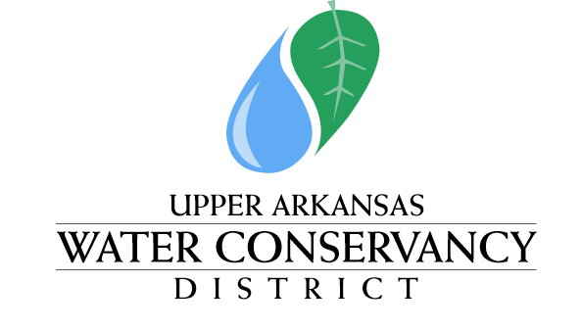

NOTICE AND AGENDA

Notice is hereby given that a regular meeting of the Upper Arkansas Water Activity Enterprise Committee will be held at the Upper Arkansas Water Conservancy Building, 339 East Hwy 50, Salida, CO, and by REMOTE ELECTRONIC VIDEO AND AUDIO CONFERENCING commencing at 1:00 PM on July 9, 2020.

ENTERPRISE COMMITTEE MEETING
339 E. Hwy 50
Salida, Colorado 81201
July 9, 2020
1:00 PM

Approval of Minutes from Meeting of June 11, 2020

Approval of Financial Reports
- Monthly Income Statement
- Quarterly Balance Sheet Review – (April, July, October, & January)

Manager’s Report - Terry Scanga
- Augmentation Report

Hydrology Report – Jord Gertson
- Reservoir Storage

Engineer’s Report – Chris Manera
- Deferred to District Board Meeting

Legal Report – Law of the Rockies - Kendall Burgemeister
- Deferred to District Board Meeting

Other Business

Adjourn

POSTED: July 8, 2020
AT THE OFFICES OF THE UPPER ARKANSAS WATER CONSERVANCY DISTRICT
339 East Hwy 50, SALIDA, COLORADO

