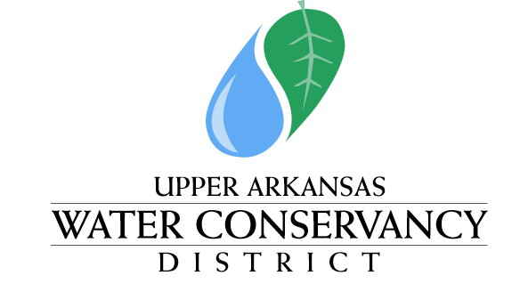

339 East Hwy 50 ~ P.O. Box 1090 ~ Salida, CO 81201 ~ Phone 759-539-5425

NOTICE & AGENDA

Notice is hereby given that a meeting of the Upper Arkansas Water Conservancy District Human Resources Committee will be held at the Upper Arkansas Water Conservancy District Building, 339 East Hwy 50, Salida, CO, commencing at 1:30 p.m. on April 29, 2024.

HUMAN RESOURCES COMMITTEE MEETING
AGENDA
April 29, 2024
1:30 PM

- Approval of minutes from October 12, 2023 & March 18, 2024
- Prepare for Interviews of Prospective General Manager Candidates
- Consideration of Executive Session

POSTED: April 28, 2024
AT THE OFFICES OF THE UPPER ARKANSAS WATER CONSERVANCY DISTRICT
339 East Hwy 50, SALIDA, COLORADO

Committee Members: Tim Canterbury, Mike Shields, Tom Goodwin, Richard Hilderbrand, Greg Felt –Recused;
Staff & Consultants: GM Ralph Scanga, and Legal Consultant Kendall Burgemeister

*There will not be a remote option for attendance.

