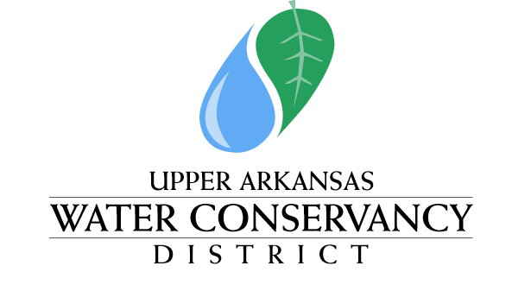

339 East Hwy 50 ~ P.O. Box 1090 ~ Salida, CO 81201 ~ Phone 759-539-5425

NOTICE & AGENDA

Notice is hereby given that a meeting of the Upper Arkansas Water Conservancy District Human Resources Committee will be held at the Upper Arkansas Water Conservancy District Building, 339 East Hwy 50, Salida, CO, commencing at 8:30 a.m. on May 9, 2024.

HUMAN RESOURCES COMMITTEE MEETING
AGENDA
May 9, 2024
8:30 AM

- Approval of minutes from April 29, 2024
- General Manager Candidate Interviews

Consideration of Executive Session pursuant to: C.R.S.§ 24-6-402(4)(c), to protect matters required to be kept confidential by state law, which are the application materials and information for non-finalist candidates for the General Manager position pursuant to § 24-72-204(3)(a)(XI)(A); C.R.S.§ 24-6-402(4)(f)(I) to discuss personnel matters related to the search for a new General Manager; C.R.S.§ 24-6-402(4)(b) Conference with an attorney for the District for the purposes of receiving legal advice on specific legal questions relating to the search for a new General Manager;

POSTED: May 8, 2024
AT THE OFFICES OF THE UPPER ARKANSAS WATER CONSERVANCY DISTRICT
339 East Hwy 50, SALIDA, COLORADO

Committee Members: Tim Canterbury, Mike Shields, Tom Goodwin, Richard Hilderbrand, Greg Felt –Recused;
Staff & Consultants: GM Ralph Scanga, and Legal Consultant Kendall Burgemeister

*There will not be a remote option for attendance.

